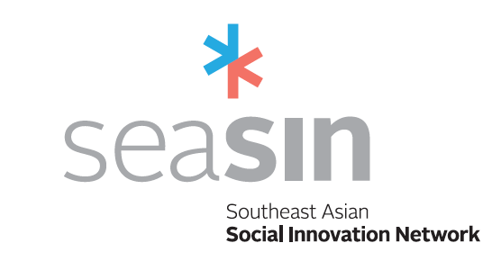

WP3: Development
GENERIC “Social Innovation Support Unit” (SISU) MODEL

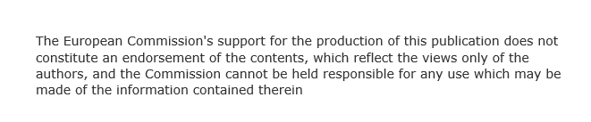

Authors (WP leaders):
NUM - National University of Management Team
UA - University of Alicante Team

Version: 2 June 2017

CONTENTS

EXECUTIVE SUMMARY 3
INTRODUCTION 6
1. STRATEGIC POSITION WITHIN the HEI 8
2. PHYSICAL SPACE 11
3. APPROACH, OPERATION and METHODOLOGIES 14
3.1 SISU Values 14
3.2 SISU Specific Objectives 14
3.3 SISU Characteristics 14
3.4 SISU Team 15
3.5 SISU Generic Process 16
3.6 SISU Operational functions 17
4. SISU IMPLEMENTATION 22
4.1 Implementation plans for Tailor-made SISUs 22
4.2 SISU Operational Plan 22
4.3 SISU Users 24
4.4 SISU Additional Activities 26
4.5 SISU Staff 28
4.6 SISU Equipment 30
5. CHECKLIST 31
ANNEX 1: Analysis of the specifications for the Physical Space 33
ANNEX 2: Example of SISU in Thammasat University 34
ANNEX 3: Examples of SISUs in Latin America 36
ANNEX 4: Evaluation of the SISU 40

EXECUTIVE SUMMARY

The intention of this work package is to give an outline of the characteristics of a generic SISU model for SEASIN partners. The SISUs (Social Innovation Support Unit) will specifically aim to widen the scope of regular knowledge transfer activities and offer special shared incubation space. These spaces will not simply work as a social business incubator, but rather they will develop the tools and resources to build an ecosystem in which social innovations can grow and flourish. In particular, they will be designed to achieve the following:
● Help social innovators to prototype solutions with appropriate equipment;
● Increase in new social enterprises and projects;
● Identify and leverage new funding opportunities, including microcredit resources;
● Encourage collaborations between university academics and social programmes in order to lend academic credibility;
● Develop new innovation models (foundations, cooperatives, not-for-profit companies etc.);
● Standardise measurement of social responsibility based on benchmarking such as ISO26000 or ASHOKA change-maker status offered to internal and external, private and public organizations;
● Become involved in international networks in social innovation;
● Develop measurement procedures to assess both social and economic impact of social innovation initiatives;
- Transfer University training and research results to the wider societal context.

Why are SISUs important for Universities and the community?
● SISUs contribute hands-on experience to the learning process;
● SISUs connect learning experiences to the social context;
● SISUs boost innovative ideas and maximise impact;
● SISUs can engage with the community;
● SISUs provide students and academics with the capacity, motivation and experience to engage with the community;
- SISUs can contribute to strengthening the role of the University in social development.

A SISU is:
- A space for dialogue, where different societal stakeholders (e.g. policy makers, academics and experts, representatives of a local organization or community, and the private sector) are invited to engage with each other, to discuss their ideas and create innovative solutions in order to tackle commonly recognized problems or discuss issues where there may be conflicting perspectives. This means that a SISU does not act only when ideas are already developed, but it actively works to foster new ideas, by encouraging new collaborations and relationships; and making connections between the different stakeholders in society (this is one of the key drivers of social innovation);

- A space for innovation and co-design, where new ideas can be developed with a participatory and co-design approach between universities and society. By being based in higher education institutions, the SISU participates in this co-design and participatory process by providing its own internal resources (staff) and allowing society to access resources available within the university (academics, students, tacit and codified knowledge, infrastructure, space, networks etc.), and bringing together different stakeholders in society to one place (citizens and communities; public and private sector etc.).

- A feedback channel, from society to the University, in order to increase the University’s awareness on the societal problems that need to be addressed. By creating participative tools, where internal and external stakeholders work together to design innovative solutions for social problems, Universities can make use of all activities as a source of data and information for a better understanding of the causes and the nature of social problems, facilitating the updating of academic curricula and research programmes.

SISU is a hub for connecting people:
- It connects universities (academics and students at all levels) with representatives of public and private bodies; including policy makers, decision makers, managers, civil society representatives, community groups etc.
Specifically:
Academics: social innovators and anyone from the SEASIN network will be able to contact academics in order to receive the necessary guidance.
Representatives from private bodies: industry will be able to generate inputs related to prototypes, products, services and models for social innovators.
Representatives from public bodies: public managers/public servants will be able to generate inputs on how social innovators can integrate with current policies, including access to finance.
Experts: SISU should incorporate suitable experts for mentoring social innovators.
A SISU strategically brings people together at a time when persistent problems, disruptive changes or a crisis demand that stakeholders come together to make new sense of the situation. It is about bringing the right people together to engage in:
- Sense-making, (understanding what is happening and why) which in turn infuses a situation with meaning and the motivation to act;
- Identifying the new emerging patterns, programs, initiatives, ideas that could transform the problem domain;
- Identifying the opportunities to shape or influence new partnerships, resource flows and protocols that could support such transformation.

The present document constitutes a generic model for a Social Innovation Support Unit, or SISU. It is meant to be adapted by individual universities to create a blueprint for their own SISU, so that it meets their singular institutional needs and context.

INTRODUCTION

The SEASIN project will actively promote and support University-enterprise cooperation, entrepreneurship and graduate employability with a particular emphasis on social innovation projects, incubation and collaboration with social enterprises. The project aims to establish international cooperation and internationalisation through a network of social innovation support units (SISU) across the region introducing a mentoring and transfer scheme to ensure that there is an effective roll-out of the scheme beyond the original partnership.

A SISU will be established within each HEI within the consortium. Each Partner institution will tailor the generic model to create a blueprint for their SISU that meets their institutional needs and context. The eight pilot SISU will be expected to hold an official launch in November 2017. SISUs will specifically aims to widen the scope of regular knowledge transfer activities and offer special shared incubation space. This will prove invaluable to ensure that the Universities maintain a close connection with social enterprises, government bodies, students and other stakeholders beyond the lifetime of the project and continue to support social innovation activities.

The SEASIN Partners were invited to define the characteristics of the SISU model during the project kick-off meeting. The input from the consortium has been incorporated into the SISU generic model as described in this document. This document is composed as follows:

STRATEGIC POSITION WITHIN THE HEI: this section includes recommendations of possible strategies and actions necessary for the implementation of a Unit in a Higher Education Institution; and a description of the potential institutional limitations that might be encountered. It is based on the review of guidelines and best practices in social innovation support identified during the Preparation Phases (WPs 1&2).

PHYSICAL SPACE: this section includes recommendations about the characteristics of the physical space for the operation of the SISU and is characterized as an incubation facility, including resources and equipment available as part of the SEASIN project. This section is divided into two parts: (1) Minimum Viable Product (MVP) and (2) the optimal SISU.

APPROACH, OPERATION and METHODOLOGIES: this section includes recommendations about the operation of the SISU and which methodologies and approaches could be used to support the achievements of its main goals.

SISU SPECIFIC ACTIVITIES: There are a number of specific activities developed by the SEASIN Project that may be integrated within as part of the SISU model development and maintenance. These include:

- Social Innovation Studios: specific workshops that may be implemented to complement the SISU day to day activities and support HEIs in raising awareness about Social Innovation and developing projects;
- Social Innovation Awards Programme: This programme will offer intensive training workshops to social innovators from throughout the South East Asian region;
- Doctoral Programme in Social Innovation: institutions may wish to adopt the programme to complement the SISU activities, creating a curricular activity to strengthen the knowledge base surrounding social innovation and furthering their transnational postgraduate opportunities. The program will be designed for researchers, stakeholders and multipliers of social innovation, ie all agents actively engaged in promoting the social economy.

CHECKLIST: developed to give guidance to partners, so they can review their processes or activities necessary for the implementation of SISU.

ANNEXES: detailing specific aspects about design, physical space, SISU operations, recommendations and additional resources as well as the description of the Social Innovation Studios.

1. STRATEGIC POSITION WITHIN the HEI
This section includes recommendations of possible strategies and actions to implement a Unit in a Higher Education Institution; as well as a description of the potential institutional limitations that might be encountered. This is based on the review of guidelines and best practices in social innovation support identified during the Preparation Phase (WPs 1&2).

The table below shows possible models for institutional relationships between the Units (SISU) and the HEIs.
Table: HEIs and SISUs
Typology of institutional affiliation | Example
SISU placed at high management level within the HEI:  These SISUs support a myriad of projects inside the HEI, and work as an enabling unit (working through calls for projects) | Stanford Center for Social Innovation http://www.gsb.stanford.edu/faculty-research/centers-initiatives/csi  UFRJ Pro-Rectorate for Outreach projects  http://extensao.ufrj.br/
SISU inside specific departments in the HEI:  These SISU’s are formalized as research centres or labs coordinated by a professor; or a group of professors; or other University staff member and area (VP of Innovation). | Social Innovation Institute UDD-FMK  http://iisocial.udd.cl/en/  DESIS Lab Politecnico di Milano ( http://www.desis.polimi.it
SISU as an incubator  These SISU’s are formalized as incubators or part of existing traditional incubators (as a section specifically dedicated to social innovation) | Thammasat University, Thailand  http://www.sgs.tu.ac.th/index.php?id=75&i=41&1-glab-about-overview
SISU as a specific project  These SISU’s are constituted as specific projects that exist to foster SI practices between university and society | Lien Center for Social Innovation, Singapore  https://lcsi.smu.edu.sg/about-us  Bertha Center for Social Innovation - University of Cape Town – http://www.gsb.uct.ac.za/berthacentre
SISU as a combination of different previous strategies  These SISU’s are specific projects, run from a specific department and/or operate similar to an incubator | The Waterloo Institute for Social Innovation and resilience (WISIR) – http://sig.uwaterloo.ca/

By reviewing these examples, different kinds of institutional affiliations emerge that are currently being used to promote social innovation in HEIs. Each of these affiliations has advantages and disadvantages, and these should be considered carefully in relation to the specific conditions that each SEASIN partner will find within their own HEIs and how their individual SISU will develop. Each university must find the best institutional model for their SISU.
According to the input of the SEASIN Partners at the workshop carried out during the project kick-off meeting, certain challenges might need to be overcome in defining the institutional model for the SISU in the university:
● Partners should take the time to make University decision-makers understand the need for a SISU within their institution, in order to have their full support for the set-up and running of the SISU;
● Partners should work with University decision-makers to identify appropriate physical space that can be made available to set up the SISU;
- Through the project partners can purchase technical equipment for the SISUs, but not furniture. They will therefore have to either address their own Higher Management in order to be allotted furnishings, or recruit external sponsors to help cover the cost of furnishing the SISU;
● Partners directly involved in SEASIN and the set up of the SISUs should liaise with other actors in their University who may already be working in Social Innovation in a number of faculties or institutes, and should look into coordinating activities with them.

Based on the activities in WPs 1 and 2 and input from the Advisory and Evaluation Committee, the generic SISU model will define, instruments and processes for raising awareness within the university community, fostering social innovation as an integral part in the institutional activities in knowledge transfer and offering an incubation facility with hot-desking space and other facilities for students.

The criteria that define the minimum operational activity level required for a SISU are:
● There must be a meeting point for people/professors interested in Social Innovation;
● There must be a social incubation centre.

However, strategically, we would recommend the following activities for a SISU:
● Operating as a centre for research
● Accelerating projects
● Providing tools for professors/classes to foster social innovation
● Acting as an interface between the university, society, and surrounding communities.

2. PHYSICAL SPACE
This section includes recommendations about the characteristics of the physical space for the SISU. It is characterized as an incubation facility, and includes resources and equipment made available as part of the SEASIN project. The proposal contains what is considered to be the minimum requirements for an effective SISU, and then recommended facilities for the medium to long-term development of a SISU.
A Social Innovation space (Minimum required) is needed in order to establish a physical space where people can gather together. This space must contain a co-working space where people can work collaboratively and openly as well as private offices where stakeholders can have private meetings.
In order to foster the social innovation process within the institution, the space should be equipped with the appropriate facilities. These could include resources such as 3D printers and laser cutters but a simple and important element is also the design of the space itself. The space needs to be attractive to students, entrepreneurs, professors and members of the wider community interested in social innovation and entrepreneurship.
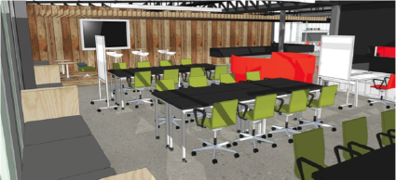
These criteria have been developed from the input of the SEASIN Partners at the workshop carried out during the project kick-off meeting and the limitations proposed by each university. Specifically, we would recommend the following:

- Co-working space (Minimum required): This is an open space for students and community meetings, talks and exhibitions related to innovation. This should be flexible and mobile, with furniture and resources allowing this versatility.

- Front Desk (Minimum required): Virtual or physical space where users have access to generic information regarding the SISU. This front desk can be virtual, for instance, a website; or physical, or both. This is the place where the SISU’s objectives and contact information is available for anyone interested in knowing more.

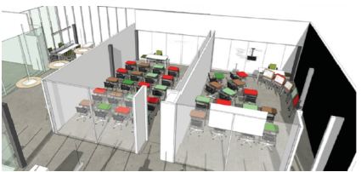

- Technological Exploration: This is space exclusively dedicated to machinery and equipment that allows SISU users to prototype and explore possible solutions to their needs. This space should include 3D printers, laser cutters, computers, technological exploration material and other machinery needed to develop technological projects.
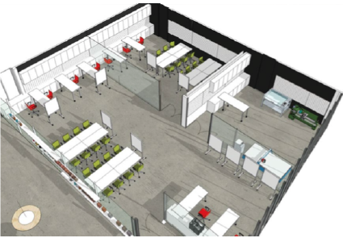

- Classroom: This is a space where lectures, talks and other forms of workshops and small events can take place without disturbing entrepreneurs and innovators working in other areas of the SISU.

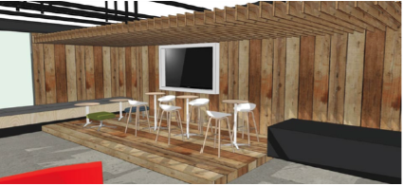

- Scenario: This space should have two functions -an area which can be used as a space for relaxing and having informal conversations, but also one which can be used for special events and talks with larger groups of people.

3. APPROACH, OPERATION and METHODOLOGIES
This section includes recommendations about the operation and activities of the SISU and which methodologies and approaches could be used to support the achievement of the SISU’s main objectives.

3.1 SISU Values
- It represents an innovative strategy to develop solutions for social problems;
- Greater diversity of skill means greater possibility;
- It encourages a collaborative physical environment;
- It progressively builds local development;
- It creates commitment with social issues.

3.2 SISU Specific Objectives
The specific objectives of a SISU are to foster social innovation as an integral part in the institutional activities in knowledge transfer and encourage a university-society engagement with local communities and in particular disadvantaged groups through a variety of means:
- New social enterprises;
- New participative and collaborative projects;
- New business and funding models, including microcredit and crowd funding resources;
- Project- academic credibility, specialist knowledge;
- New robust and viable innovation models;
- New quality standard models for social responsibility;
- Capacity building to expand their influence through larger, international networks;
- Collection of data on social issues and solutions;
- New initiatives for the communities.

3.3 SISU Characteristics
A SISU should have the following characteristics:
- Creativity: the SISU is a creative environment, which is not only generated by the physical spaces it offers but also through the people who work within it. The SISU encourages the presence of people in their facilities. A SISU encourages people to use spaces and resources available to develop ideas, projects and also enhance and generate knowledge.

- Collaboration with society: a SISU will not deliver or provide a top-down solution to a society, as “experts from university” providing knowledge to “passive citizens” but will recognize the diffused creativity available in society and that social innovations often emerge from bottom-up initiatives such as citizens’ activism, emerging spontaneously from a specific group of people. A SISU recognizes and relies on existing capabilities and resources in people and institutions.

- Open-door policy: a key policy of a SISU should be to have an open-door policy in order to attract social innovators but also any kind of stakeholder. This is a key factor for supporting projects but also to raise awareness inside and outside SEASIN’s institutions. In this way, a SISU is a hub that connects multiple stakeholders around societal problems.

- Mutual-learning process: a SISU will foster knowledge exchange between universities and society in a mutual learning process. Universities recognize the knowledge embedded in society (e.g. Traditional knowledge) and, at the same time, they make scientific and technological knowledge available to society. This defines the innovative status of a SISU using new and resourceful strategies to tackle societal demands.

- Innovative copyright policy: social innovations are the result of collaborations between different stakeholders in society to face commonly recognized challenges. Traditional copyright policies may not be appropriate in a SISU if it is to foster the right environment for the development of social innovation, it might hinder the process.
- Academic credibility: an active SISU contributes to academic credibility in the realm of social innovation (as universities have done in scientific and technological innovation through institutes and dedicated centres).

3.4 SISU Team
Coordination: the coordination part of the team is responsible for all strategic decisions related to the SISU operation and its resources. Faculty members and technicians should support and collaborate with the coordinator(s).
Advisory board: is composed of specialists and senior researchers who can advise the coordinators and SISU users on areas related to the SISU activities.
Technical staff: support is needed for administration and management of the technological resources and physical spaces in the SISU. They should have the skills to operate machinery (for example the 3D printers and laser cutters).

3.5 SISU Generic Process
About the process
As mentioned before, a SISU can take different formats depending on the structure and strategy of each HEI. However, a SISU must foster social innovation and raise awareness within the university community. For this reason, we introduce here a generic SISU process to be used as a guide and a recommendation on each HEI’s designing process.
A clear process is useful as a tool for partners to define how to approach the design of a SISU. Additionally, a clear process can be shared with the SISU’s stakeholders, so they know how and when to participate. The number of stages or projects that each HEI starts with does not matter, but using the process as a guide is important. It is then possible to add or remove stages later depending on the appropriateness of each stage.
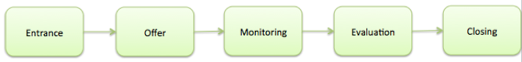

The SISU generic process has 5 stages. It starts with an entrance, where new individuals enter the SISU. The SISU process ends with a closing stage, where the individual leaves the SISU because he or she fulfils the requirements established by each HEI. In between, the process contains an offer module, where the entire social innovation support is described and delivered to the individual or group (users) who enter in the SISU process. This module is followed by a monitoring and evaluation stage designed to keep track of the advances of each individual or group, also to be able to continuously improve the process being provided by the SISU.
A SISU may have the following characteristics at each stage:
- Entrance: this includes the materials, resources and dissemination of the SISU opportunities among students and HEI staff (it may include an email sent out with an invitation to visit the SISU website and look for opportunities).

- Offer: this includes a menu of activities and resources to promote and empower Social Innovation (SI), which includes specialized support, capacity building, SI courses, boosting strategies.

- Monitoring: this includes the supervision of the activities in progress, to ensure they are on course and on schedule to meet the goals defined by participants. It includes requirements defined by the SISU coordination.

- Evaluation: information from the monitoring stage can be used to update the participant’s goals and observe any partial results. The goals should be defined earlier in the process in a participatory procedure (with individuals and groups involved) and must be related to what is going to be monitored. It includes criteria defined by the SISU coordination.

- Closing: it is required to define an "exit strategy", that is, when the SISU support will not be required. This is an important point in the process and should be clearly defined. It will depend on whether the project itself will end, or will continue on its own without SISU support when it is considered developed and sustainable enough to do this.

3.6 SISU Operational functions
To realize the approach described above and operate effectively, a SISU should serve a dual role:
●SISU in an active mode: it operates as a catalyser, actively looking for social innovation/enterprises to be involved with;
●SISU in a passive mode: it operates as a balcony, being constantly available to support local actors;

1. SISU as a catalyser
The SISUs catalyse the existing potential for social innovation in the society, actively looking for opportunities for social innovation/enterprise to develop. In this model of action, a SISU does not operate as a “balcony” where it would be waiting to be used and contacted by social actors; rather it goes beyond the university, interacting with institutions and communities. This stimulates new ideas that are emerging and developing, converging in the development and implementation of new ideas (products, services and models) to meet social needs and create new social relationships or collaborations (c.f. Guide to Social Innovation. European Commission).
Relying on existing knowledge, an interesting example of a catalyser process comes from the EU project TRANSITION ( http://transitionproject.eu/learning-outcomes/project-methodology/ , it is shown in the picture below:
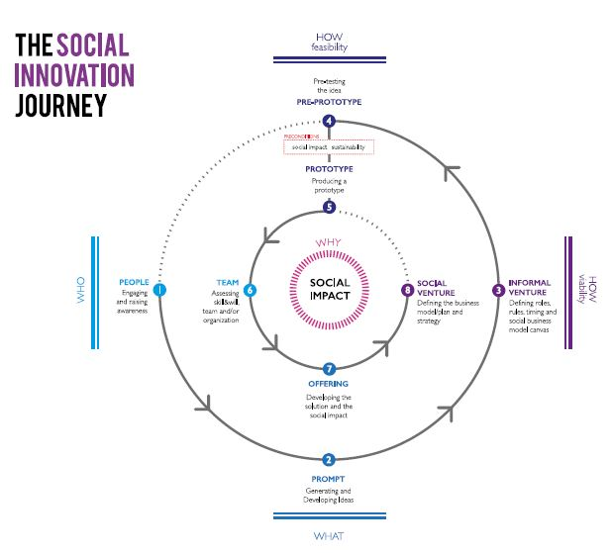
The TRANSITION project considered that “Social innovations often emerge from bottom-up initiatives, from citizens’ activism, from spontaneous group of neighbours. TRANSITION action format aimed to support innovators from the very early stage of an idea, to empower communities to grow solutions to social needs and raise awareness around them. Moreover it aimed at delivering supporting activities to groups and innovators usually excluded from traditional path of incubation.” (from TRANSITION project website:http://transitionproject.eu/learning-outcomes/project-methodology/ )
Therefore, the very beginning of this process is to “raise” awareness (1): “Find and activate potential social innovators. This is an in-depth phase to be centred on the explicit or implicit awareness of the social innovators of their role and actions. It allows, in parallel, for light to be shed on hot topics. Awareness could be raised through direct contact with local initiatives and promoters, so as to present them with the possibility of supporting them through the design process/tools/output” (Meroni et al, 2015, http://goo.gl/6n5l8f).
Other example that runs in the catalyser logic is the Social Innovation Institute (IIS) located on the Department of Innovation and Development of Universidad Del Desarrollo (UDD).
The mission of the Institute is to prepare change makers who will give a new solution to existent social challenges. To prepare those change makers the IIS offers innovative courses to teach the concept, but also innovative programs to insert social innovation in the regular schools’ syllabus or create new instances of hands-on learning and impact. In that way, the purpose of enabling change makers through capacity building can assist those students to search for demands and ideas outside the university and bring those concerns to the IIS and develop a project or an enterprise to solve the problem.
The IIS encourages evidence-based policies to boost social innovation. To accomplish that, the IIS is working on several studies with its associate researchers. The research covers topics such as social innovation ecosystem, social entrepreneurs or senior entrepreneurship, that kind of knowledge can help the development of transformative projects.
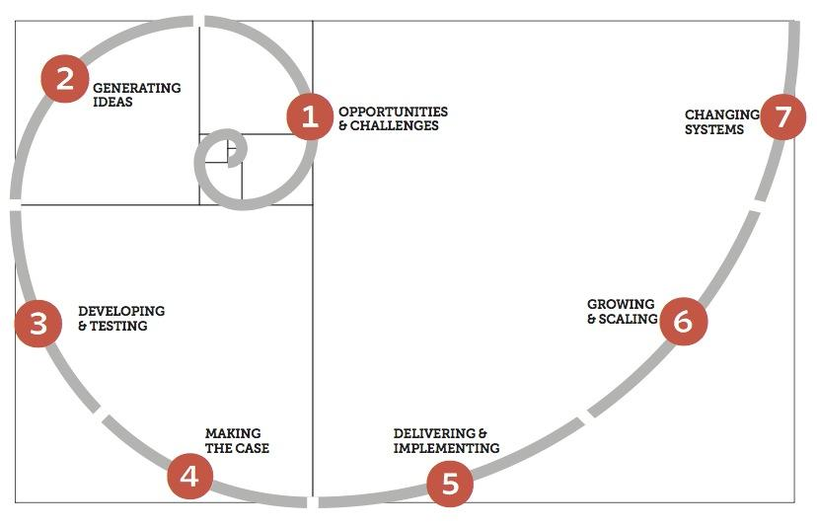

2. SISU as a balcony
The SISU is open to any demand brought in by social actors. In this model, the SISU operates as a balcony and has a less active role in searching for opportunities in social innovation. In this way, social actors contact the SISU in order to promote a personal idea for a social enterprise or a social innovation project and the unit offers support to develop those ideas with its principles and processes.
Relying on available research, an interesting example of how this approach could work comes from the DIY (Development Impact and You), a platform built by NESTA (http://diytoolkit.org/). They develop a set of tools "specially designed for practitioners to dive straight into action. Yet the tools presented here are grounded in existing theories and practices of innovation, design, and business development.” There is a useful framework for understanding “how to put ideas to work, and focusing on the different methods, and different mindset, needed at each stage” for developing social innovation from established opportunities or identified demands. The seven stages of this framework are showed below:
Opportunities & challenges: This phase involves diagnosing the causes of a problem, or identifying the opportunities that a new change could bring about. In the balcony model, the social actor has already identified this opportunity and needs help developing it and deepening the problem research.
Generating ideas: Use creative methods like design to increase the number of solution options from a wide range of sources.
Developing & testing: In a trial and error process, ideas are iterated and strengthened. This can be done by simply trying things out, or through more rigorous prototyping and randomised controlled trials.
Making the case: Before trying to implement the idea, firm evidence must be built up to back it up and then share it honestly.
Delivering & implementing: Includes identifying what is working well, and what is not, as well as securing income streams that enable the long term financial sustainability to carry the innovation forward.
Growing & scaling: In this stage there are a range of strategies for growing an innovation – from organizational growth, to licensing and franchising. Emulation and inspiration also play a critical role in developing an idea or practice in a more organic and adaptive manner.
Changing systems: Systemic innovation is where maximum social impact can be produced. It usually involves changes in the public and private sector over long periods of time, and the interaction of many elements and new ways of thinking.
Source: http://diytoolkit.org/
We suggest HEI teams to do a literature review to find the best approach, either for the balcony or for the catalyser model. Also, we recommend that the HEI teams check the institutions mentioned in the first part of this deliverable under the section “Strategic position within the HEI) to understand their operations and get insights into their methods.

4. SISU IMPLEMENTATION

4.1 Implementation plans for Tailor-made SISUs
Implementation plans for Tailor-made SISUs
● Adapt the generic model according to the institutional structure and organizational characteristics, of each HEI/ social environment;
● Incorporate regional recommendations by members of the Evaluation and Advisory Committee;
● Incubation facilities using the equipment costs allocated must be incorporated into the plans.
● Each SISU will undertake to support a minimum of 15 projects involving a minimum of 60 individuals (inside and outside the university) through engagement in a variety of activities as described in the present document, as well as through workshops, seminars, contests, etc.
● After the first six months of activities, the Advisory and Evaluation Committee will carry out an assessment visit and generate a report containing a series of recommendations and improvements.

4.2 SISU Operational Plan
At each stage it is possible to identify different strategies. Here are some possibilities to be explored:
- Entrance:
  - SISU as a catalyser carries out an active search for individuals and projects. This option requires planning and specific activities for awareness raising and events to attract new users.

  - SISU as a balcony: It could utilise a passive strategy of receiving users who have actively decided to enter in the SISU process. In order to achieve this, the SISU must have a well-designed and highly visible space within the University.

- Offer: There are a number of possible services offered by the SISU which must be well defined and resourced. Below is a list of (non-exhaustive) examples:

  - Specialized Consulting
    - Legal
    - Design
    - Business Model
    - Marketing
    - Accountability
    - Financial Sources
    - Social Issues

  - Entailment
    - Internal articulation (departments/researchers/experts)
    - External articulation (NGOs/government/communities)

  - Capacity Builder
    - Courses
    - Workshops
  - Boosting
    - Mentoring
    - Networking activities
    - Accelerator
    - Incubator
- Monitoring: The items and characteristics to be monitored are defined by each partner in relation to their facilities and resources.

- Evaluation: The evaluation should be done considering the monitoring and the criteria and goals are defined by each partner.

- Closing: The projects should have reports and consolidated data to feed into further analysis and a portfolio of results.

Important aspects to be considered:
Participatory process: each SISU should foster a participatory model where social innovators can benefit from contribution at all stages of their project or initiative.
Networking: each SISU relies on the SEASIN network to get support from other SEASIN organizations. This can enhance the performance of any social innovator and stakeholder, allowing them access to other perspectives.
Mentoring: one of the main issues that should be included in the participation process is Mentoring from experts. The possibility to receive advice from more experienced practitioners should be one of the key benefits for social innovators.
Partnerships: partnerships between the SISUs, the public sector, private sector and society (specifically NGO´s, Collectives and others community associates) are an important point that seeks to foster partnerships between stakeholders, thereby helping raising awareness.
Financial support: financial support should not necessarily be provided from the SISU budget, but each SISU must be ready to guide social innovators towards entering into fundraising processes.

4.3 SISU Users
This section describes specific users (from the academic community to wider society) of the services provided by the SISU. Taking into account, the two operational models proposed above, different social actors are recognized as possible SISU partners and users. It is important to identify these potential stakeholders within the regional ecosystem as an integral part of defining the offer that the SISU presents.

1. SISU as a catalyser
Although the direct beneficiaries of this action will be the higher education institutions and training organisations themselves - researchers, teachers and students, the project will also directly impact on a variety of entities and individuals engaged in social activities: policy makers, community and educational organizations, indigenous peoples, local authorities, NGOs, professionals, SMEs, and women and youth organizations.

Since this approach involves the SISU as active in engaging social actors and searching for opportunities for social innovations/enterprise to happen; the main partners and users were identified as:

University community (technicians, students and professors): This is a group that can represent a partner in searching for opportunities and working on social innovation projects in society, and also can be a user of the SISU service when the unit itself facilitates processes of engagement and ideation with the university community in order to foster opportunities for social innovation.
Government: public managers/public servants could generate inputs on how social innovators could be integrated with current policies. Government institutions such schools, hospitals, community centres and others can be good places to search for new ideas and social innovation projects, therefore, the government and its institutions can be both partners and users of the SISU service.
Social Projects/ NGOs: In spaces where the social concern is already a reality, there are opportunities to identify and problem-oriented social innovation projects. This work can be done in these organisations but also in their territory, with the groups they work with or with specific demands they might have.
Local Communities: Local communities are spaces that have a specific culture and can be empowered to participate and identify social innovation projects. A collaborative process can involve and approach these communities in order to develop ideas for social innovation projects to solve local problems.
Informally organized groups: There are engaged groups that organize themselves informally and can be a fertile space to develop ideas for social innovation. These groups already have strong leadership, which can empower the community/neighbourhood in the collaborative process.
Private Enterprises: Private enterprise can be a good partner for social innovation projects and a good source of new opportunities, especially in the social responsibility context.
Other HEIs

2. SISU as a balcony
While the catalyser model has the SISU in an active role, searching for new opportunities to foster social innovation, in the balcony model the SISU operates as a receiver of ideas from different actors. In this approach, the aim is to develop the idea and enable people to carry it forward.
All the actors described before (in the SISU as a catalyser section) can also be acknowledged in this model. Adding to these, there is another actor that can be a user in this approach: the individual citizen.
Individual Citizen: an individual citizen can approach the SISU in order to get support to develop a social innovation project or idea.
University community (technicians, students and professors): This is a group that can represent a partner in searching for opportunities and working on social innovation projects in society, and also can be a user of the SISU service when the unit itself facilitates processes of engagement and ideation with the university community in order to foster opportunities for social innovation. As a node of Social Innovative programmes among all the stakeholders, Universities have the opportunity to describe and disseminate successful methods in the application of Social Innovation.
Government: public managers/public servants could generate inputs on how social innovators could be integrated in current policies. Government institutions such as schools, hospitals, community centres and others can be good places to search for new ideas and social innovation projects, therefore, the government and its institutions can be both partners and users of the SISU service.
Social Projects/ NGOs: In spaces where the social concern is already a reality, there are opportunities to identify and problem-oriented social innovation projects. This work can be done in these organisations but also in their territory, with the groups they work with or with specific demands they might have.
Local Communities: Local communities are spaces that have a specific culture and can be empowered to participate and identify social innovation projects. A collaborative process can involve and approach these communities in order to develop ideas for social innovation projects to solve local problems.
Informally organized groups: There are engaged groups that organize themselves informally and can be a fertile space to develop ideas for social innovation. These groups already have strong leadership, which can empower the community/neighbourhood in the collaborative process.
Private Enterprises: Private enterprise can be a good partner for social innovation projects and a good source of new opportunities, especially in the social responsibility context.

4.4 SISU Additional Activities
The SEASIN project has developed specific activities that could work to support HEIs in implementing their SISU. We suggest that the tasks related to the Social Innovation Awards Programme and to the development of the Doctoral Programme in Social Innovation may be key elements in the promotion of the SISU. The first happens during SISU model prototyping phase, the second comes later on in the SISU’s development.

The Social Innovation Awards Programme guidelines and the development of Doctoral Programme in Social Innovation are not detailed in this document. They will be provided in subsequent documents available to members of SEASIN.

Social Innovation Awards Programme

The Social Innovation Awards Programme will offer intensive training workshops to social innovators from throughout the South East Asian region:

- There is already an Asian Social Innovation Award but this is based on start-up creation and is very business focussed. As a complement to this the SEASIN Awards programme will be much more focussed on the direct engagement with the community, the use of knowledge from the participant Universities and the engagement with local policy makers with a view to scalability.
- Following the call for applicants on the SEASIN website as part of the SEASIN network activities. Members of the Advisory and Evaluation Committee and partner institutions responsible for the workshops will conduct virtual and face to face work meetings, design the training workshop and select the candidates.
- Training hosts will organise the logistical details: securing a large physical space where the training activities will be conducted and cheap accommodation for participants, ordering refreshments and meals for the participants, designing timetable and programme for the various activities of the training.
- An intensive three day workshop, or ‘studio’, will be held in each country and from the best participants twelve from each partner country will be offered the opportunity to spend seven days in Europe on a mentoring visit.
- Members of the Advisory and Evaluation Committee will observe the activities and conduct an audit of the results to be presented to partners of the project as recommendations and suggestions for the future.
- Each selected participant will be expected to submit a report of their experience in Europe and how it will impact on their future activities.

Doctoral Programme in Social Innovation

The informal learning activities of the training workshops as well as the other SISU activities and in particular the research carried out in the diagnosis and benchmarking exercises, will help to develop a more formalised doctoral programme for social innovation in S.E. Asia. The program will be designed for researchers, stakeholders and multipliers of social innovation, i.e. all agents actively engaged in promoting the social economy. It will be designed to develop a body of research on SI in the region and strategies for up-scaling and transfer of SI initiatives as well as creating robust methods for measuring and evaluating social innovation to support both social enterprises and the public sector in ensuring that the social economy becomes more effective and influential in the development of policy.

The activities planned for this purpose are:
- Based on the results of research and initial benchmarking exercises and monitoring, the team will design the doctoral program in social innovation whose principal purpose will be to develop a common understanding for the promotion, design, development and management of innovative initiatives within a social, caring economy.
- The work package will also examine specific best practices and seek synergies in existing programmes such as the activities of the Centre for Social Innovation at Stanford, the DESIS network, the Skoll business school as well as the body of research that has been developed from the Social Frontiers conferences and current H2020 projects.
- As an initial feasibility study, at least two partners from the consortium will validate modules from the course designed within their own curriculum.

4.5 SISU Staff
The SISU will not simply work as a social business incubator, but rather they will develop the tools and resources to build an ecosystem in which social innovations can grow and flourish. Sufficient resources for establishing a SISU:
- Management staff for SISUs are sufficiently qualified and experienced.
- Availability of appropriate projects to benefit from SISU support.

The following briefly describes a sample of the personnel options concerning SISU operation. A SISU often begins as a very small enterprise, and may add secondments as needs arise.

SISU Manager
Duties:
- Manage and coordinate all of the SISU’s operational details;
- Liaise regarding programme section needs;
- Promoting the visibility of the SISU by engaging media both locally and abroad;
- Maintain the SISU’s budget;
- Oversee the creation of financial contracts; and
- Assists in managing the budgets of the projects.

Project Officer
Duties:
- Coordinate projects;
- Monitor and evaluate all the SISU projects, by collecting data demonstrating the impacts of the project measured against its stated goals;
- Maintain the SISU’s document;
- Oversee the progress of the projects toward the stated goals on schedule and on budget.
- Write the reports.

IT Assistant
Duties:
- Builds physical prototypes, field test them, and refine the design until suitable for production by a local manufacturer;
- Aid the SISU’s communications and publicity efforts, and/or develop prototypes and frameworks integral to the projects and processes.
- Code scalable and open-source knowledge-sharing or data collection solutions.
- Manage all of the technology-related aspects of development projects.

Administrative Assistant
Duties:
- Help to maintain the SISU finances, clerical duties, and everyday affairs;
- Create documents that help SISU participants—especially youth—track their own project progress.
- Arrange all logistic stuff for the workshops and meetings

4.6 SISU Equipment
The SISU should be fully equipped with technical equipment (computers, printers, screens, 3D printers etc.) as well as furniture.

Within the SEASIN project, partners have a budget of €35’000 to purchase technical equipment (see Annex 1), following the procedures required by the European Commission:
- Equipment is intended exclusively for the use of the SISUs in the partner country HEIs, and must appear as such in the HEI inventory.
- In the event of purchase of equipment over €25’000, documentation on the tendering procedure is needed.
- Price offers from 3 different suppliers are needed to avoid conflicts of interest.
- The beneficiaries may not split the purchase of equipment into smaller contracts below the threshold.
- The tendering and purchase procedure must also comply with the institution’s own regulations (for example, an HEI might require a tendering procedure for a purchase lower than €25’000).
- All supporting documentation must be provided to the SEASIN coordinator, and once installed the equipment must display the Erasmus+ stickers provided by the coordinator.

Regarding furniture, as it is not an eligible cost within the project budget, partners should either obtain it from their universities, or find sources of external funding to procure it. The SISU should be set up with movable tables and chairs (for example everything on wheels), so the room can be quickly redesigned for seminars, team work, workshops, etc.

5. CHECKLIST
The purpose of this checklist is to give guidance to the partners so they can review the processes or activities necessary for the implementation of SISU. This guide is specific to the requirements set out initially in the project, and at the same time leaves enough leeway for the partners to adopt a range of operations in those areas that are of local relevance, depending on the circumstances of each HEI.
NB The checklist will also be used to evaluate the SISU in November (See Annex 4 for a more detailed description of what we will be evaluating) and we will be expecting you to prepare all aspects in order to plan for the launch.

- Strategic Position
  - To whom does the SISU directly report (person/unit)? __________________
  - Strategically, where is your SISU located?
    - High Management Level?
    - Specific Department?
    - As an Incubator?
    - As a specific project?
    - As a combination of: ________________

This section is important to develop a SISU that is sustainable and high-profile. Bearing this in mind it should inspire institutional commitment.

- Stakeholders
  - List the main SISU stakeholders:

These stakeholders should be both internal and external and should include both beneficiaries and partners.

- Physical Space
  - Describe the physical space assigned to the SISU (please include photos and dimensions)

The space should be as exclusive to the SISU activities as possible and large enough to accommodate the equipment and functions defined.

- Equipment
  - Describe your SISU equipment:
    - PC _________
    - Internet _________
    - Working space ________
    - Co-working space ________
    - 3D printers _______
    - Other ______ ?

Please ensure all equipment is labelled appropriately (with SEASIN logo if possible but essential to be labelled with European Commission logo.

- Communication
  - Describe your communication strategy for the main SISU stakeholders

Communication and promotion of the SISU should be external as well as internal.

- SISU Process
  - Define your entry policy?
    - Catalyser
    - Balcony
    - Other: _______
  - Describe the main offer of your SISU to the stakeholders

How proactive is the SISU? What services do you offer?
- SISU Users
  - Identify the potential users of your SISU (include estimated numbers of users?
    - Individual Citizen
    - University Community (technicians, students and professors)
    - Government
    - Social Projects/NGO
    - Informally organized groups
    - Local Communities
    - Private Enterprises
    - Other ___________

ANNEX 1: Analysis of the specifications for the Physical Space
PLEASE NOTE: FURNITURE IS NOT AN ELEGIBLE COST FOR THIS PROJECT.

As such, the budget for equipment submitted to the Commission is as follows:

N | Detail | Cost (€)
1 | IT Equipment for SISU office (3 iMacs, printer, scanner, multimedia projector or Smart T.V. with HDMI connector, software) | €10,000.00
2 | 10 computers and 3D printers for SISU incubation spaces (if computers are less of a priority then move resources to 3D printers and perhaps also Virtual Reality (VR) technology) | €15,000.00
3 | Subscriptions to databases and online publications (and or off-line resource library containing books related to social innovation) | €5,000.00
3 | Equipment for SISU incubation spaces (pop-up stands, smartboards, video camera) | €5,000.00
TOTAL |  | €35.000.00

Any other costs (such as furniture) will represent match funding on the part of the partner institution.

ANNEX 2: Example of SISU in Thammasat University

Thammasat University’s School of Global Studies: GLab

GLab is a social enterprise incubator founded by the School of Global Studies. GLab’s three main missions are:
- Develop and strengthen capacity of CHANGELEADERS through the BA in Global Studies and Social Entrepreneurship program (GSSE)
- Foster multi-stakeholder COLLABORATION to co-create break-through social innovations.
- Skill training and workshop on the Human-Centered Design (HCD) and Social Innovation tools.

GLab doesn’t put a big emphasis on its physical space, especially given that its location is 40 km from Bangkok. GLab’s main activities fall under the categories of Co-creation, Incubation, Capacity Building, and Consultancy.

Workshops:

- Social Innovation for Education
- Leadership Workshop with Berkeley Executive Coaching Institute
- GLab Skill to Scale with Ashoka
- Human-Centered Design for Changemakers
- SE 101: 10 part course to social entrepreneurship in Thailand hosted by the Stock Exchange of Thailand

Incubation
- GLab Skill-to-Scale - A one year incubation project funded by JP Morgan and Thammasat University
- Social Entrepreneurship Mentorship Program

Consultancy
- Human-Centered Design workshop for Intel China
- Human-Design Guidebook in Thai for the Thailand Social Enterprise Office

Capacity Building
- Social Entrepreneurship for People with Disabilities
- Bangkok Social Innovation Camp
- Health Application Competition
- GLab Sandbox (Mini social innovation lab)

Other
- Design facilitator network
- D-School Bootleg/Bootcamp Translation into Thai
For current activities and photos visit GLab’s Facebook page: facebook.com/theglab/

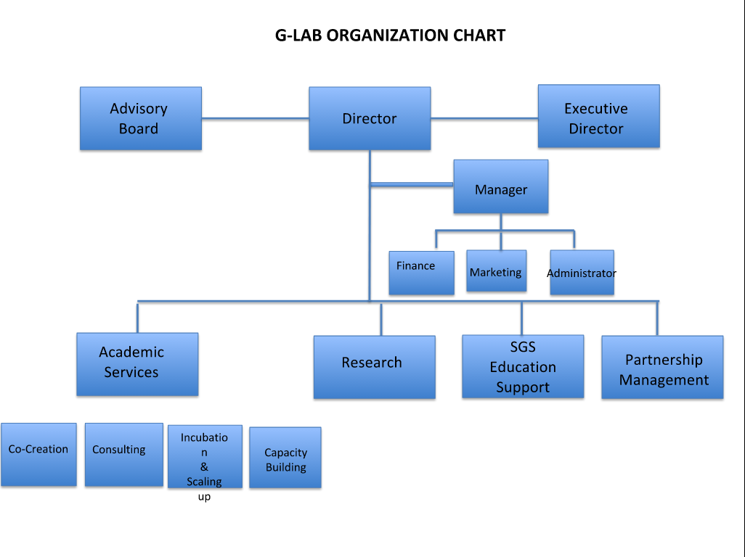

ANNEX 3: Examples of SISUs in Latin America
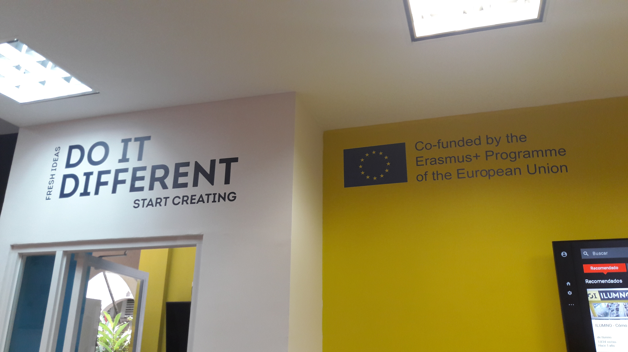
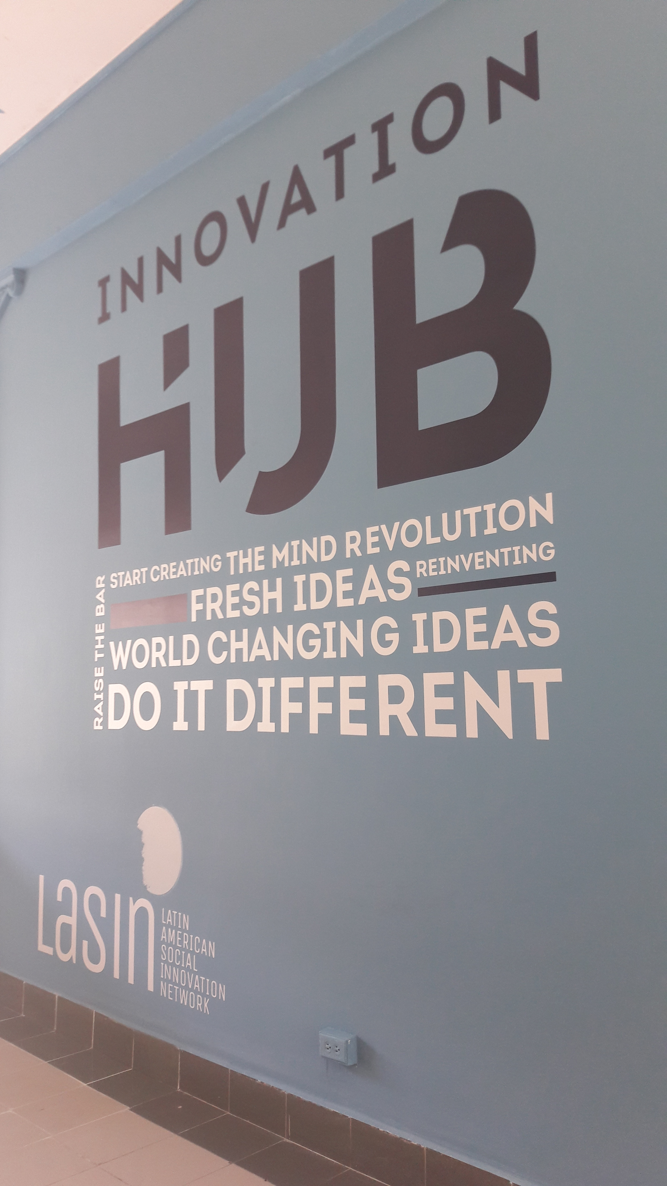
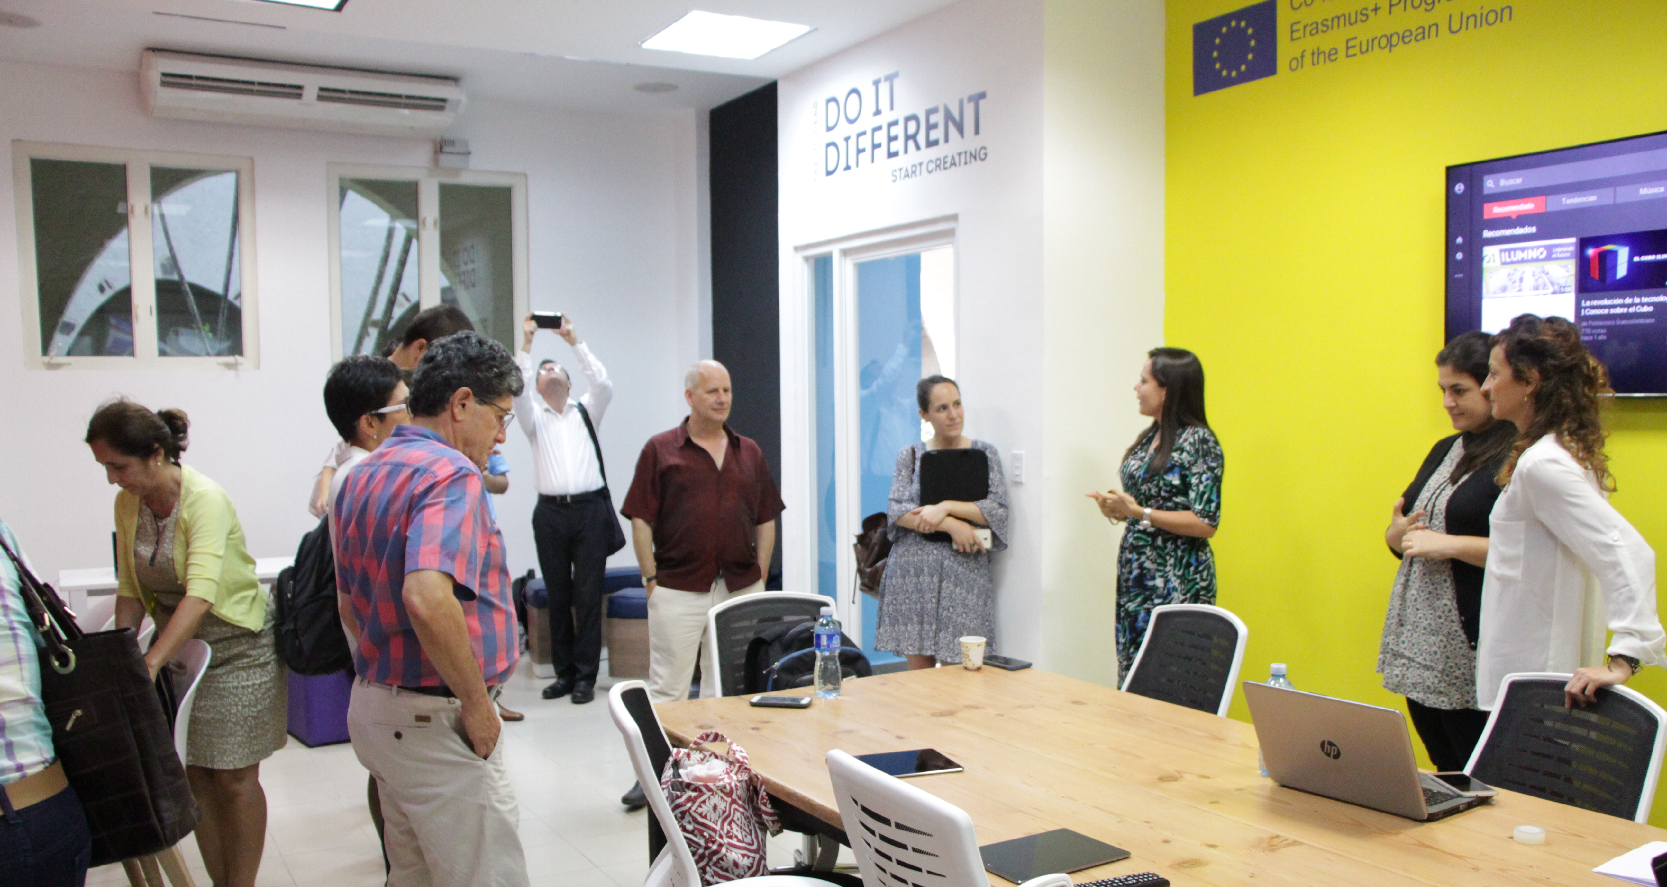
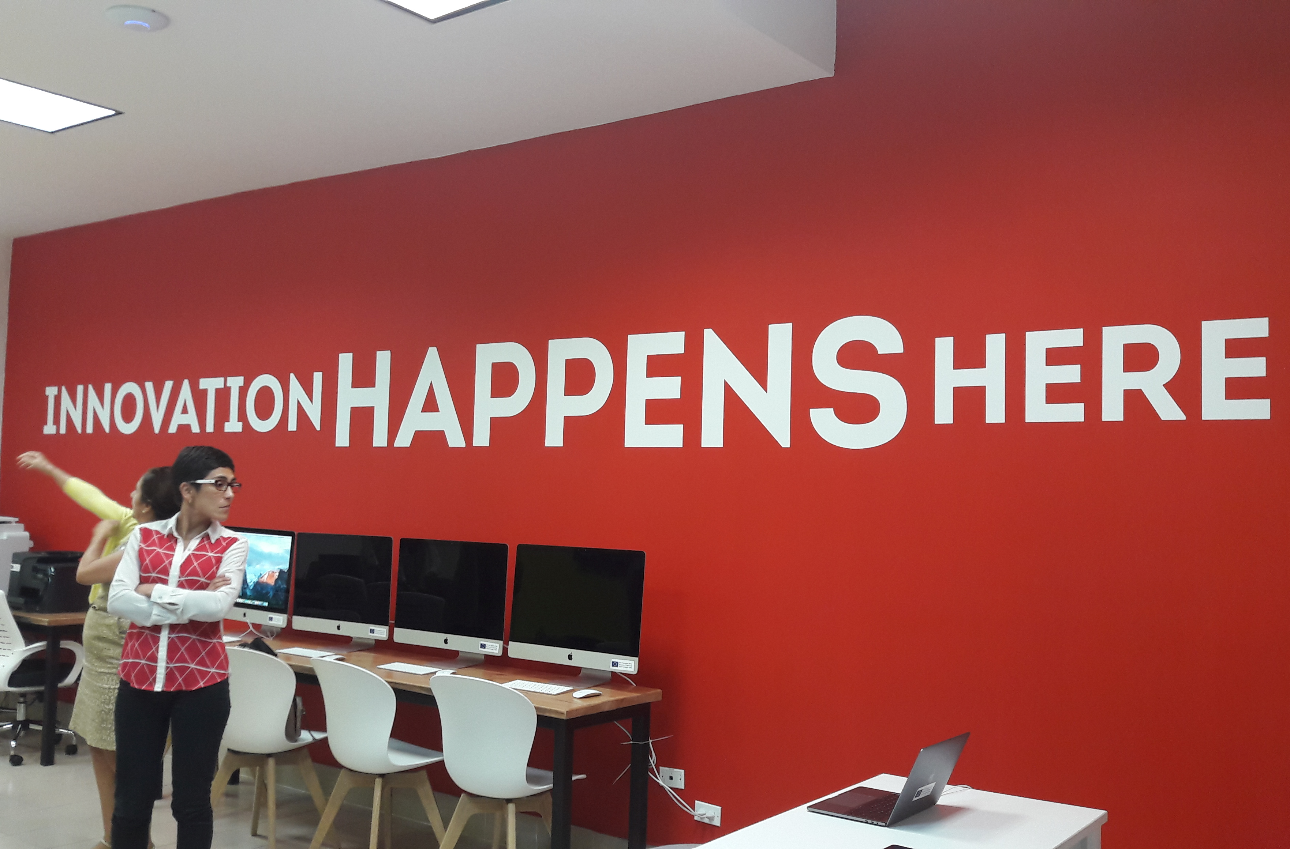
This SISU in Panama is a great example of very inspiring signage!
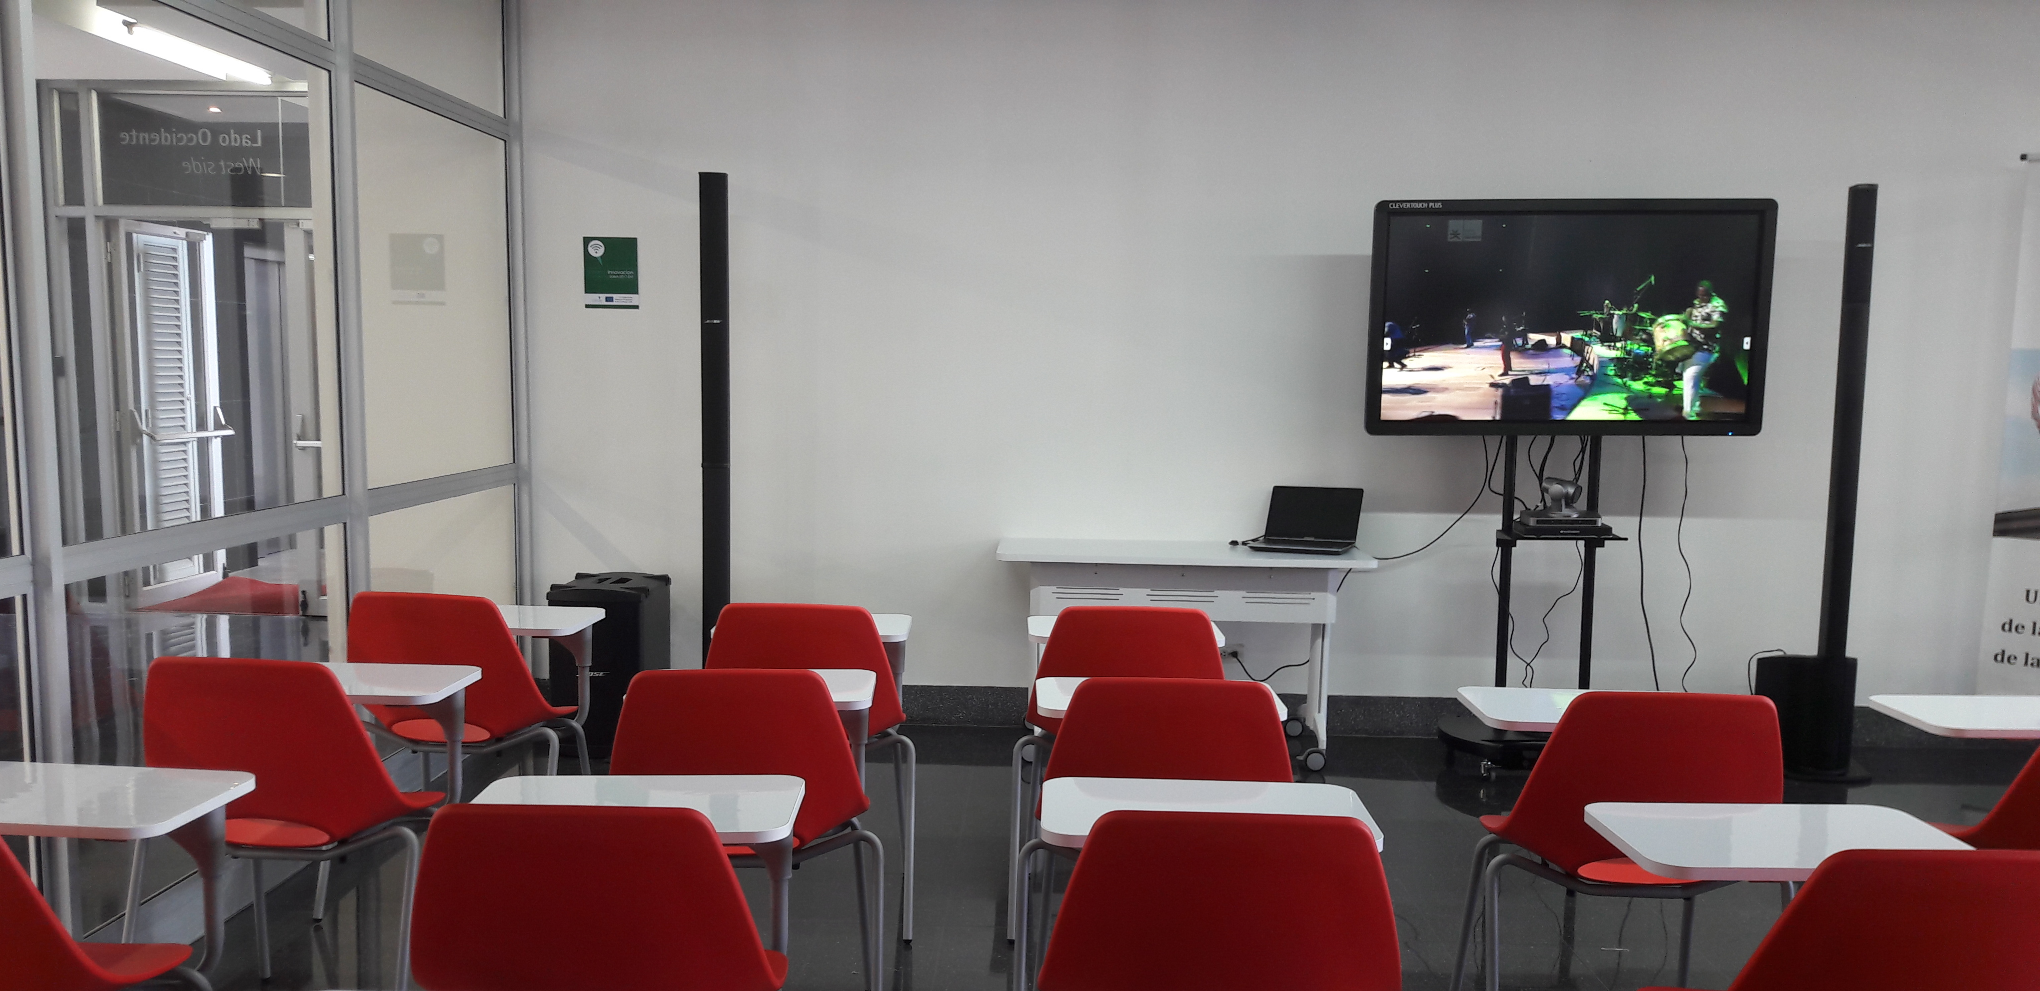
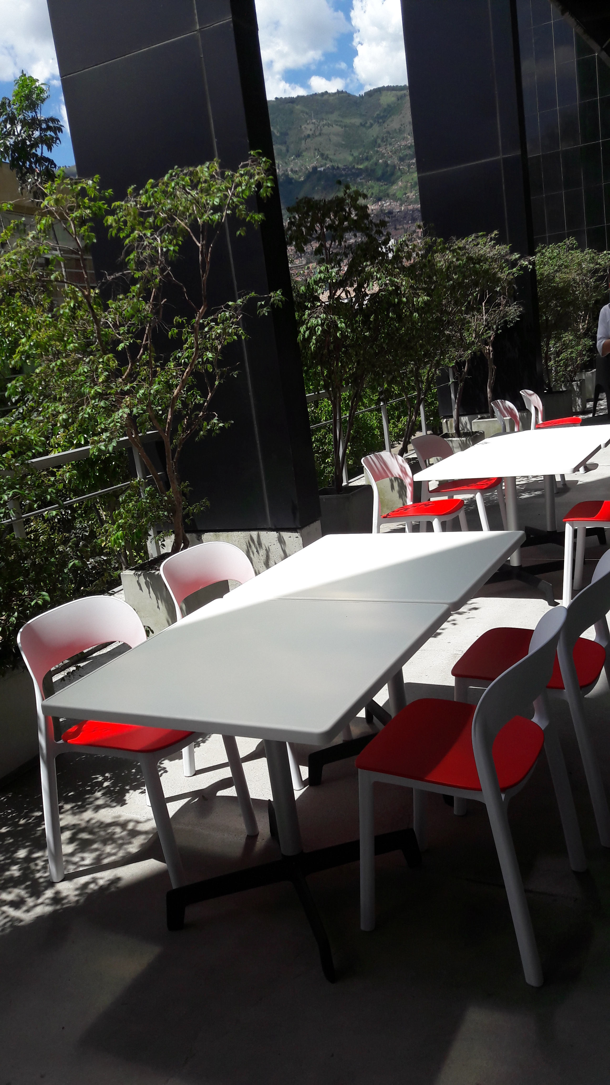
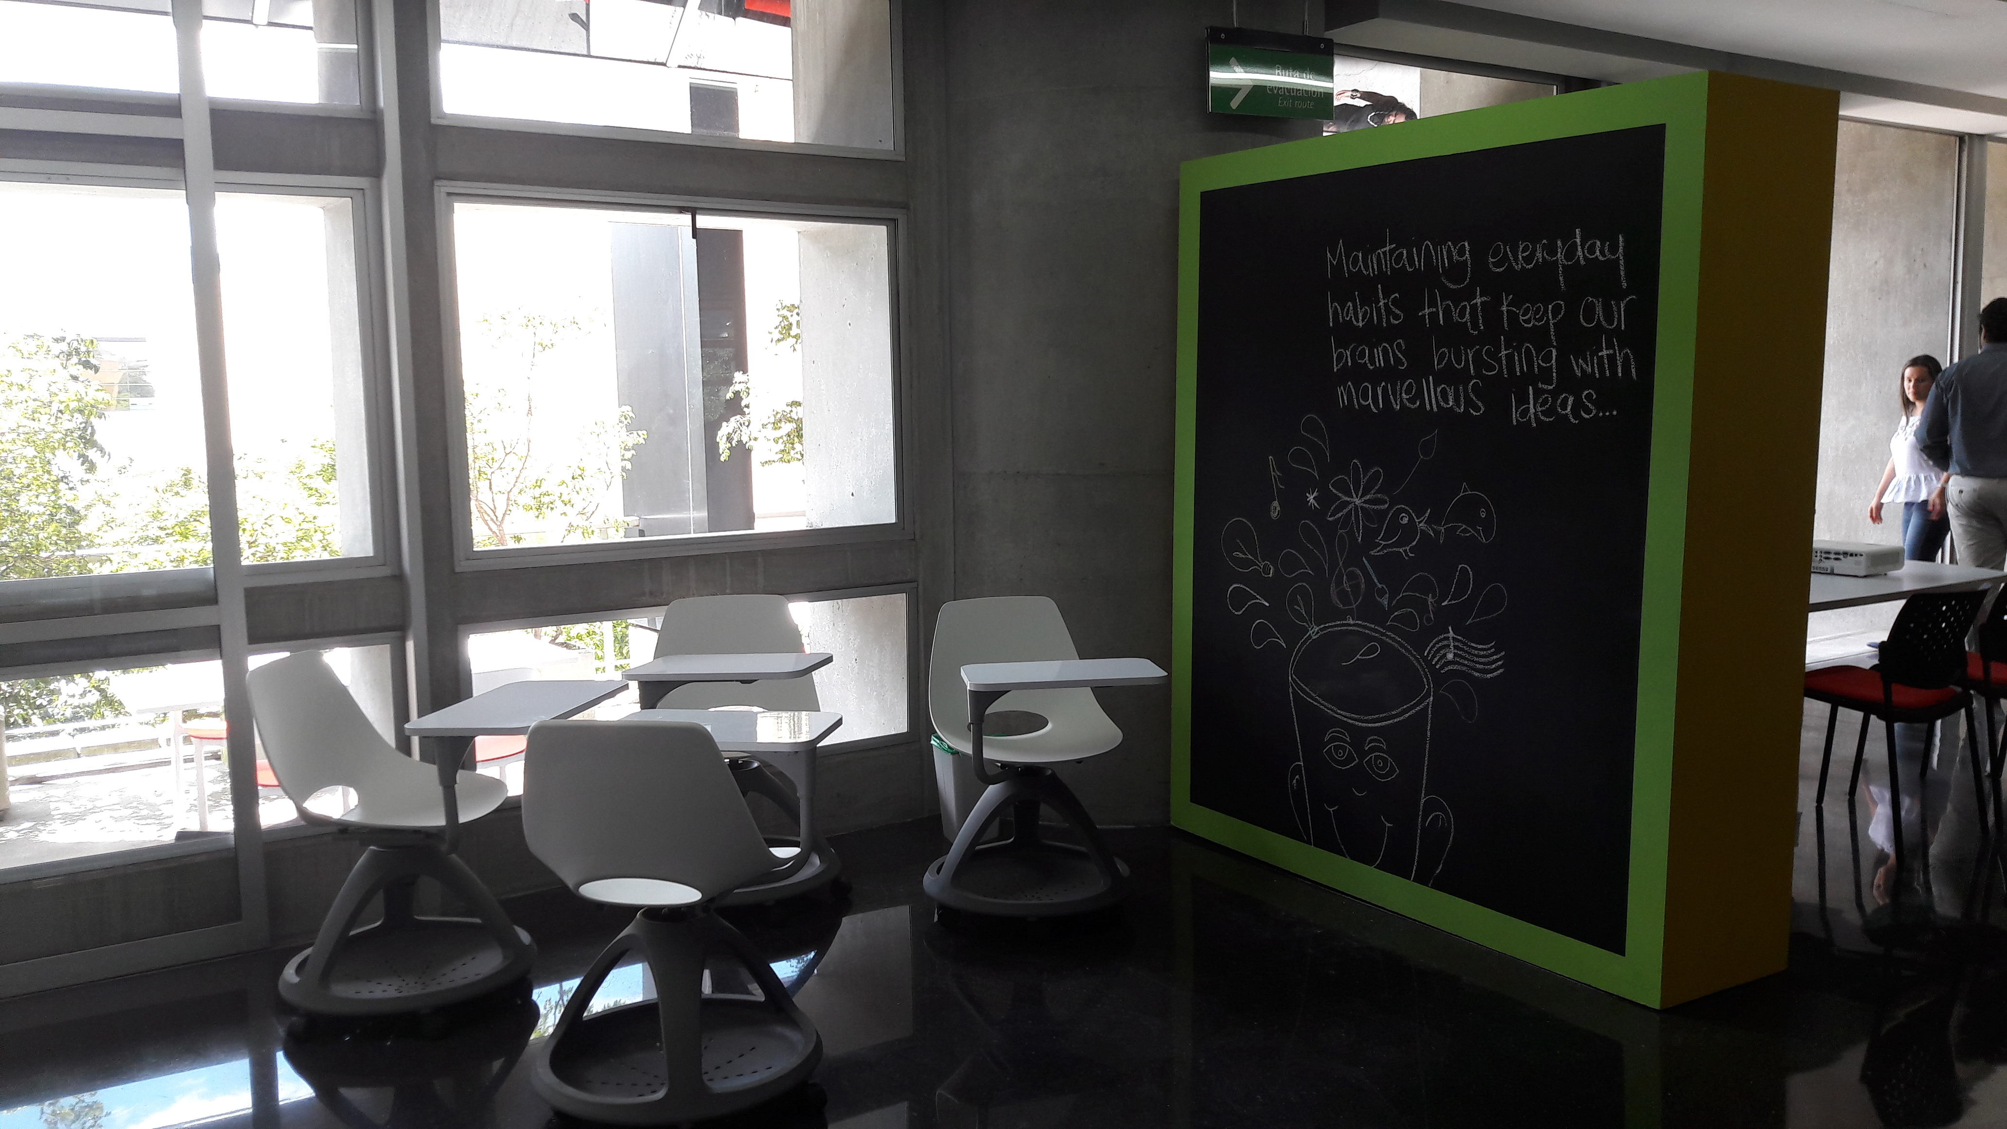
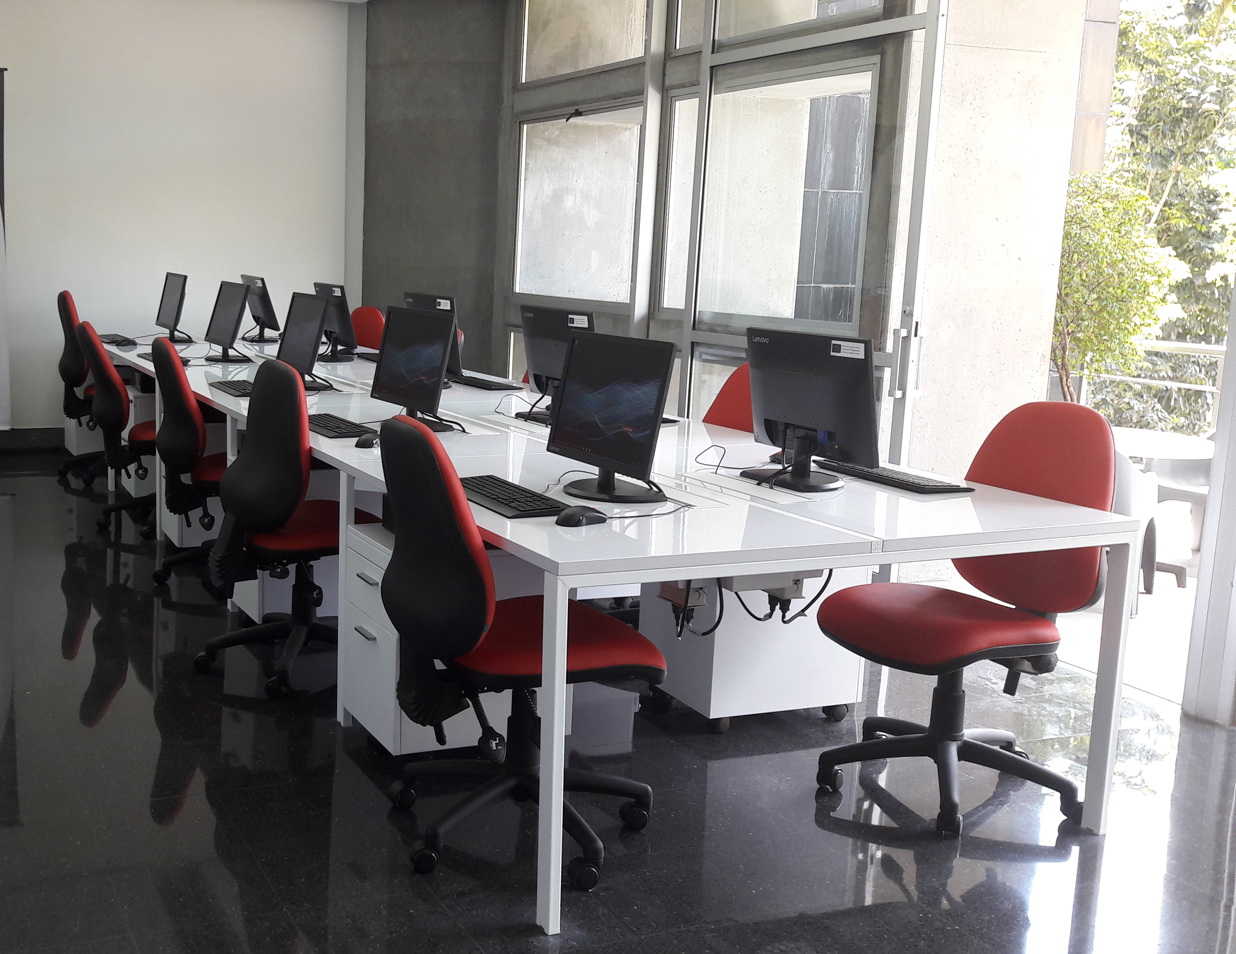

This SISU is in Medellin, Colombia and occupies a whole floor within the University.
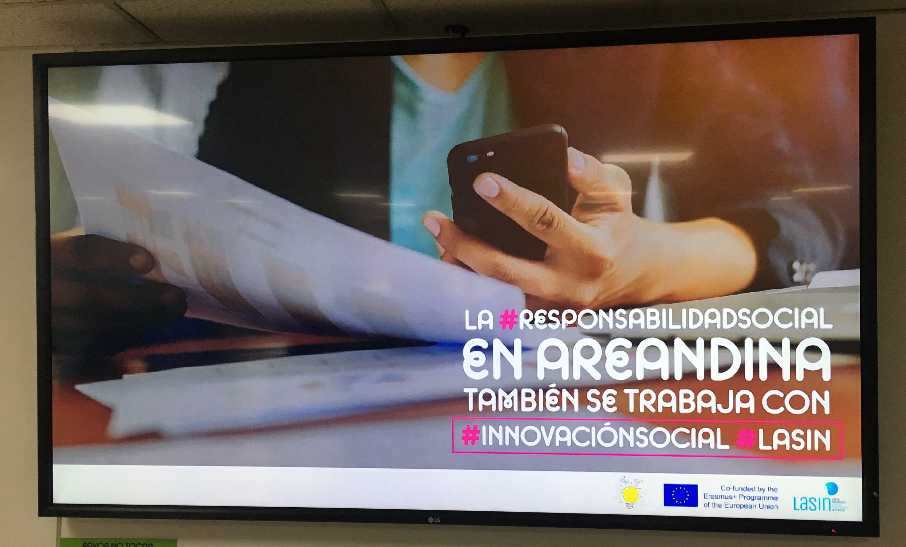
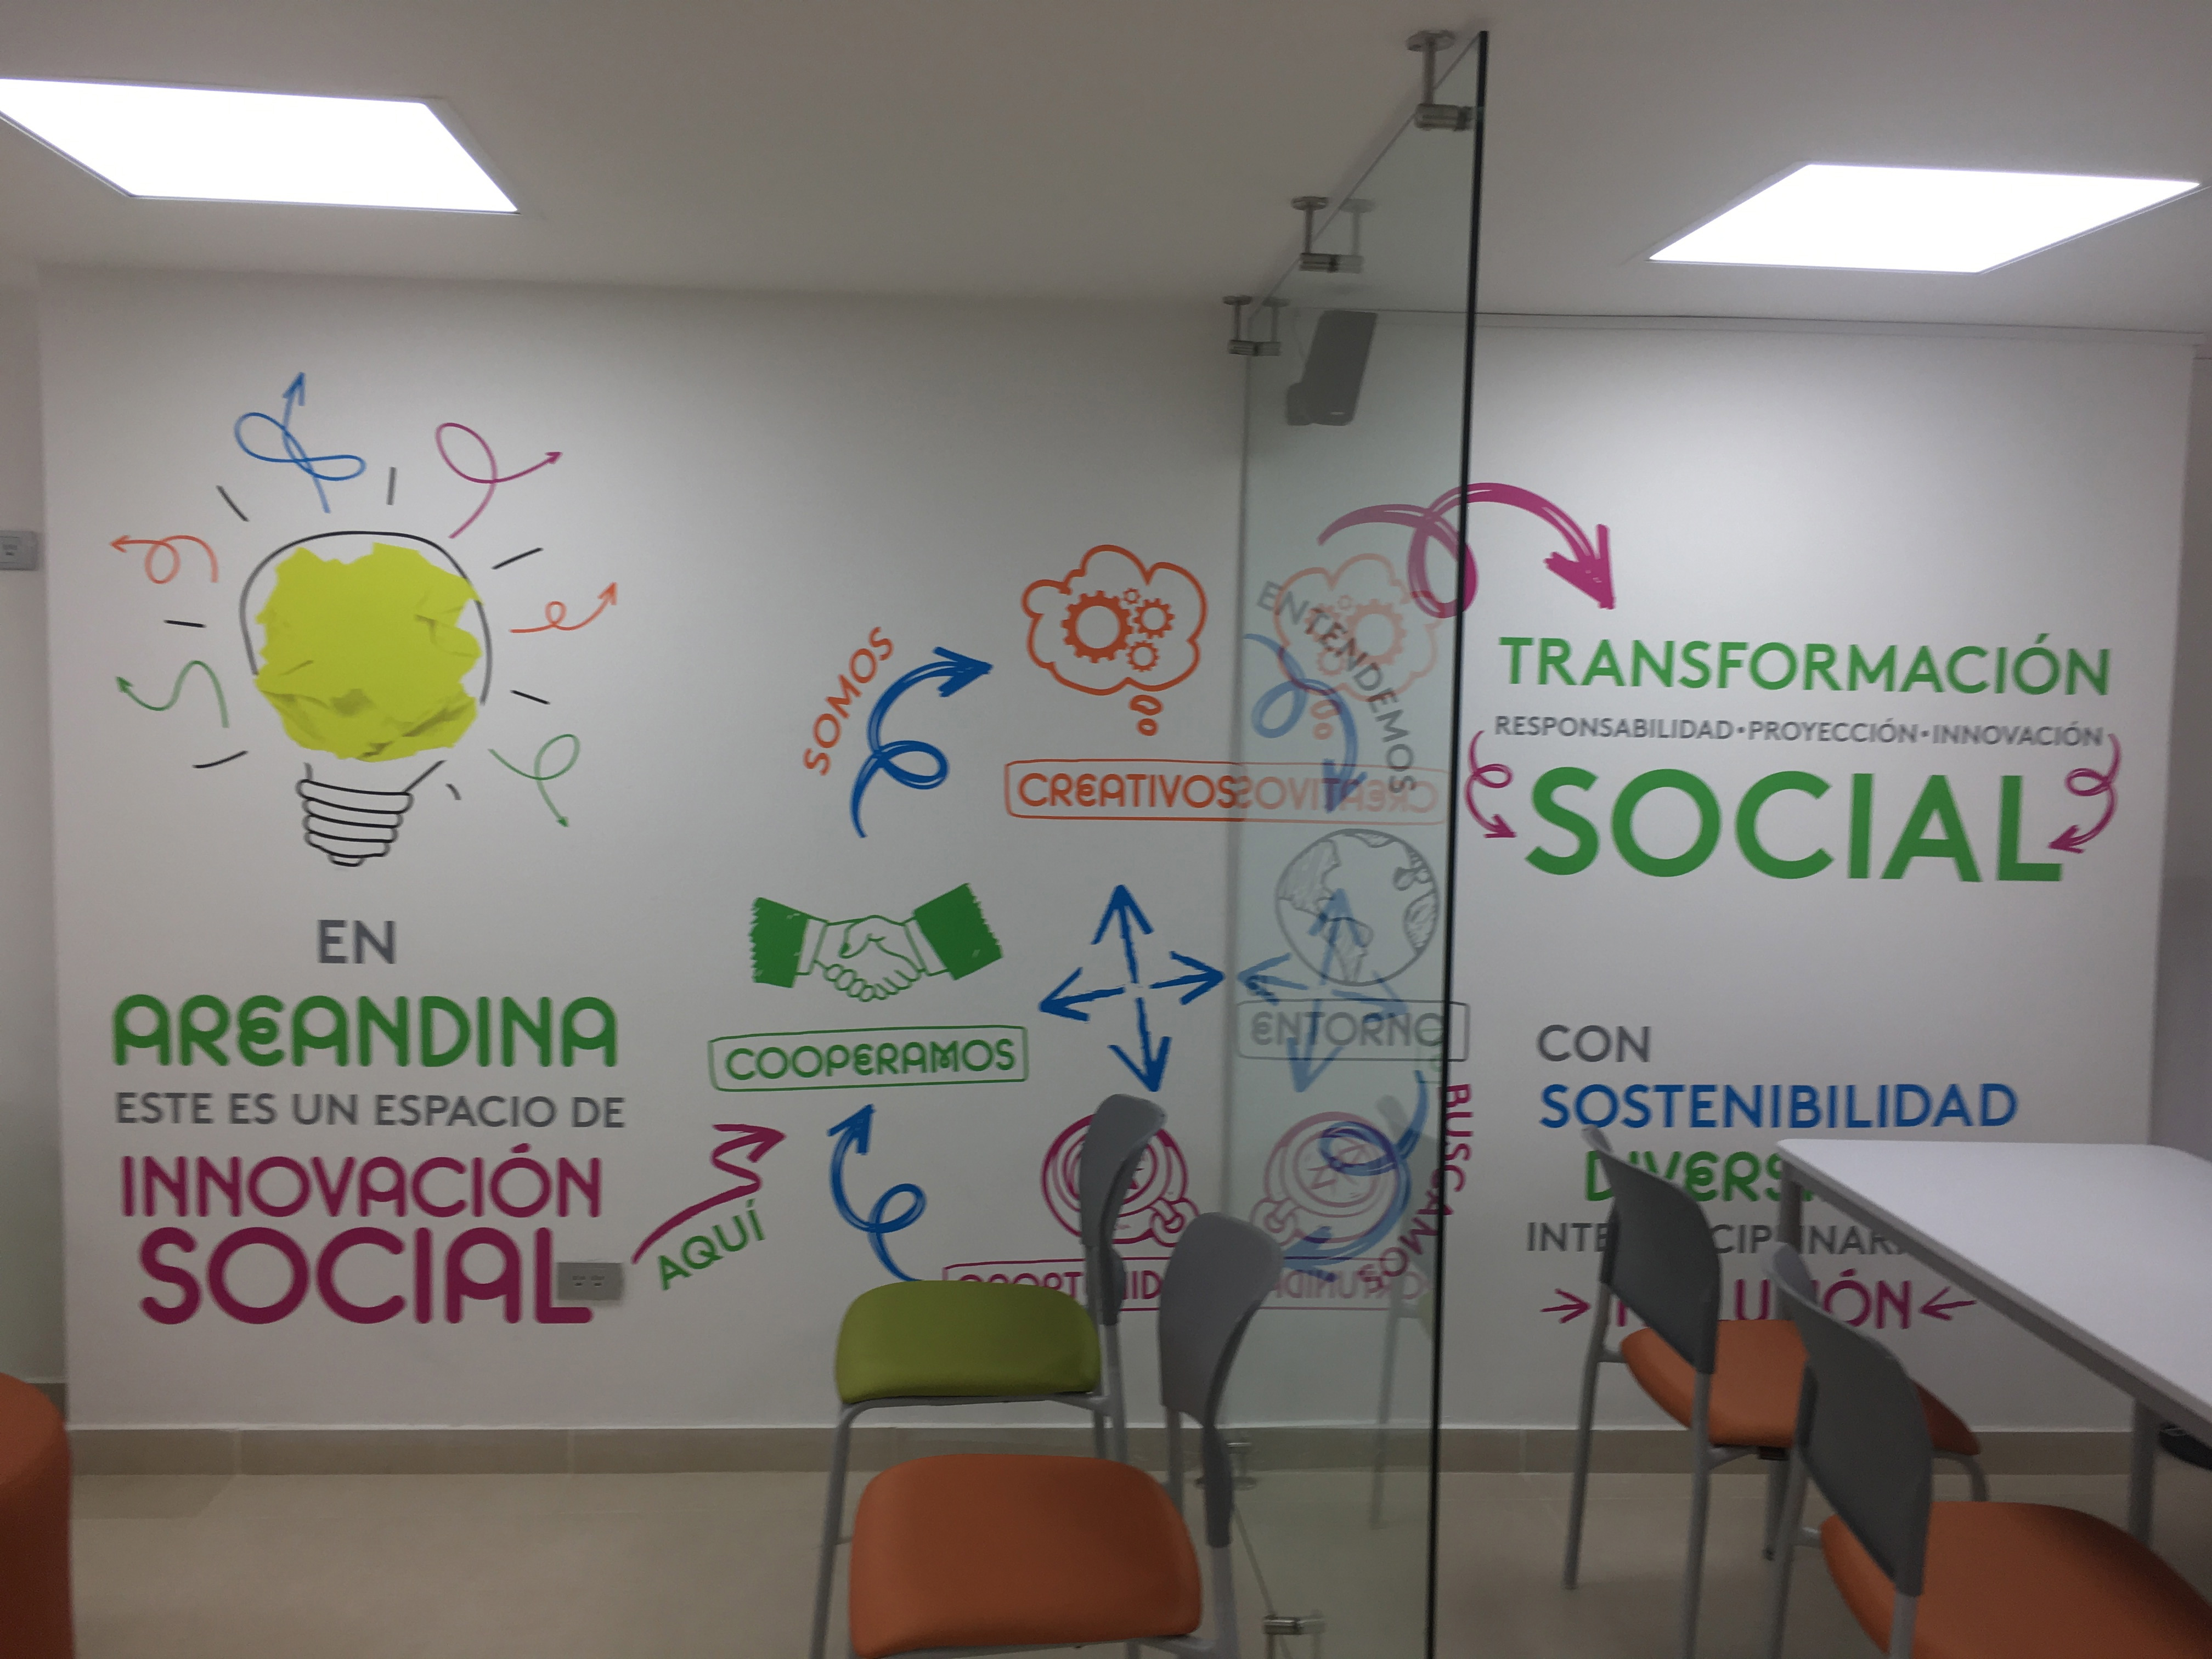
This ISU in Bogota, Colombia, occupied different spaces within the University as well as opening offices in campuses in other regions of the country.

ANNEX 4: Evaluation of the SISU

All SISU will be evaluated in November 2017. The Evaluation will reflect the Checklist in Section 5 but will require each SISU to demonstrate that they have fulfilled all the criteria. As such you should prepare a planning document and a presentation that responds to the Evaluation form below. Each SISU will be evaluated using this form.
NAME OF SISU:
INSTITUTION:
PERSON IN CHARGE:

- Strategic Position

  - What department does the SISU directly report to?

  - Strategically, where is the SISU located?
    - High Management Level?
    - Specific Department?
    - As an Incubator?
    - As a specific project?
    - As a combination of:

  - Visual presentation (Organigram) of SISU’s strategic fit (supplied by hosts):

- Stakeholders
  - List of the main SISU stakeholders:

  - Evidence of stakeholder involvement:

- Physical Space
  - Describe the physical space assigned to the SISU (please evidence with photos and dimensions)

  - Does the SISU have exclusive use of the space?

- Equipment
  - Describe the SISU equipment:
    - PC _________
    - Internet _________
    - Working space ________
    - Co-working space ________
    - 3D printers _______
    - Other ______ ?

  - Has all Equipment has been appropriately labelled.

  - Is signage clear and does it promote the SISU in an inspiring way.

- Communication
  - Describe the communication strategy for the main SISU stakeholders; what means does the SISU use to communicate its activity to the internal and external stakeholders?

- SISU Service

  - Describe the main offer of the SISU to its stakeholders; what services does it provide:

  - Define the SISU governance; does it have some kind of entry policy for users?
    - Catalyzer
    - Balcony
    - Other: _______

- SISU Users
  - Describe the potential users of the SISU (include estimated numbers of users?
    - Students
    - Academic staff
    - Individual Citizens
    - University Community (technicians, students and professors)
    - Government
    - Social Projects/NGO
    - Informally organized groups
    - Local Communities
    - Private Enterprises
    - Other ___________

- SISU Projects.

  - Describe at least FIVE projects supported by the SISU (please ensure that there is EVIDENCE for these projects).

v)

